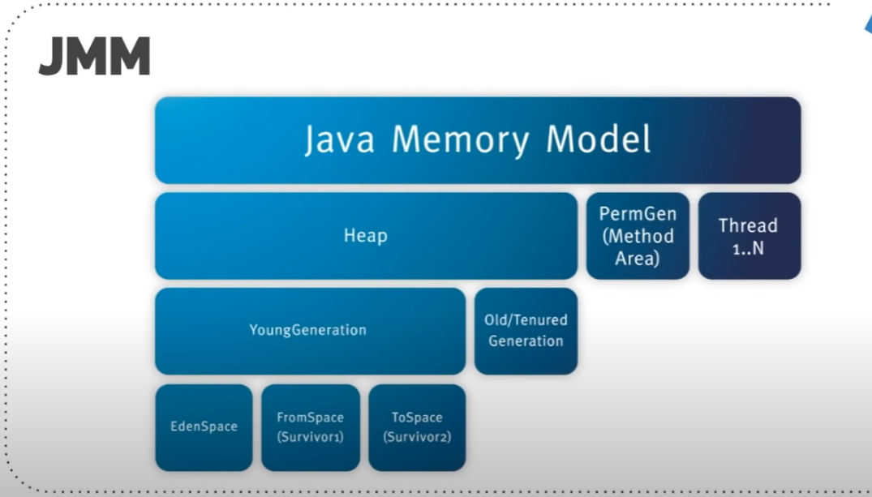

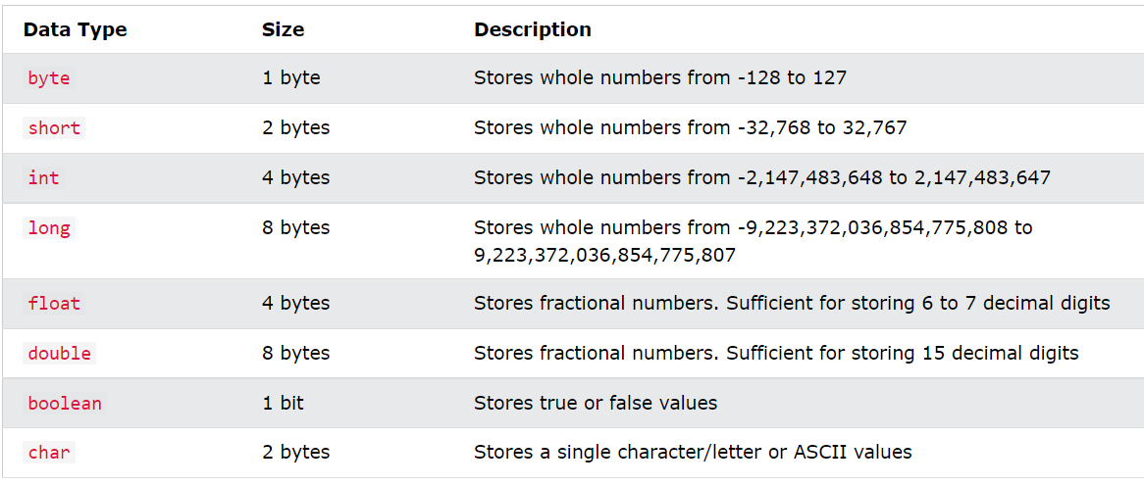

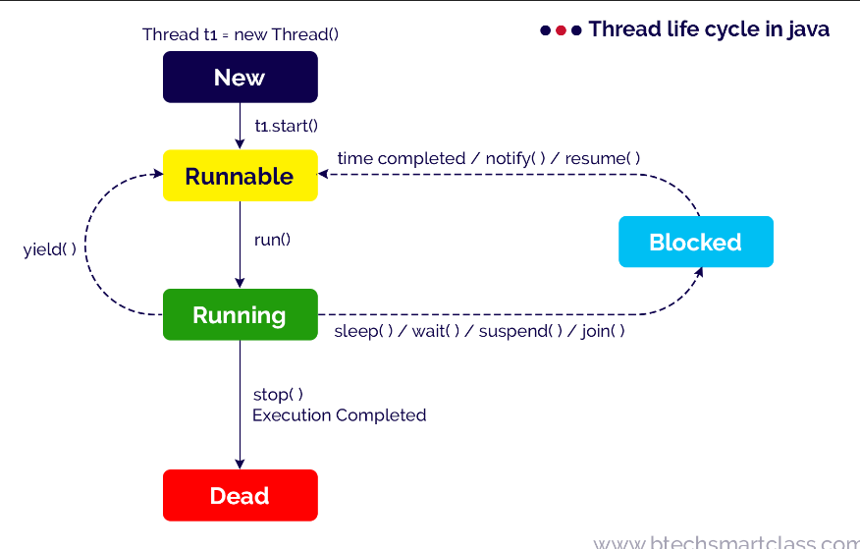

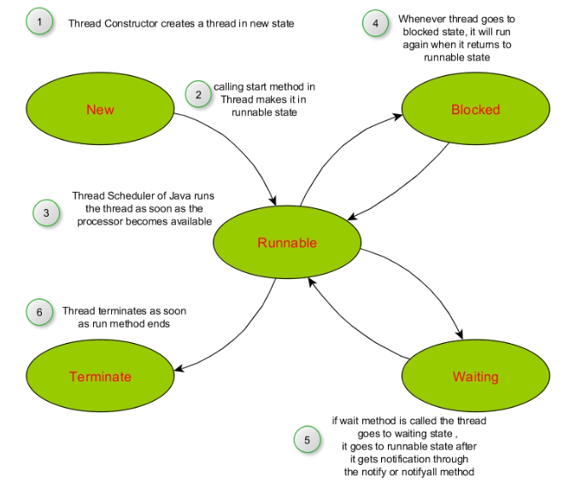

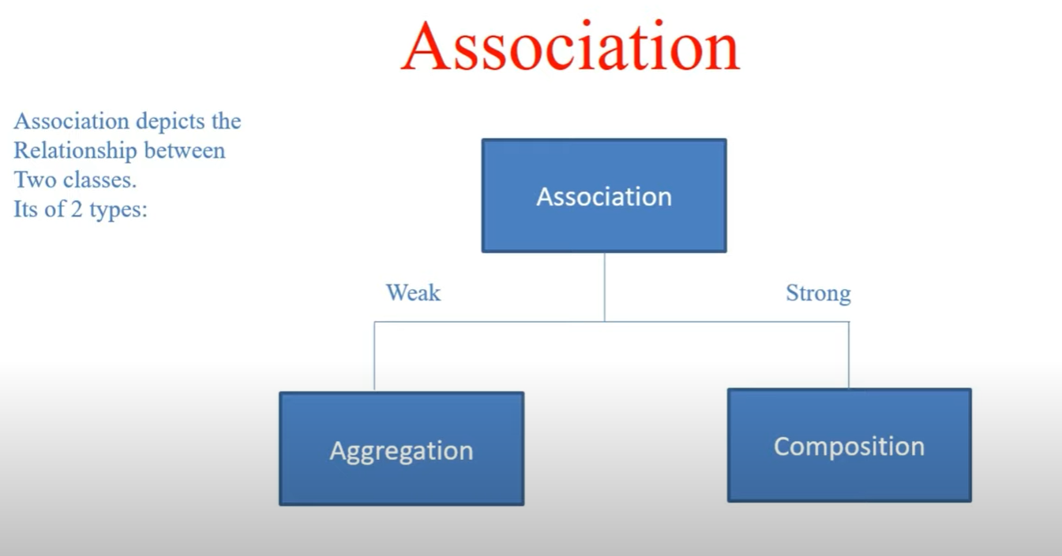

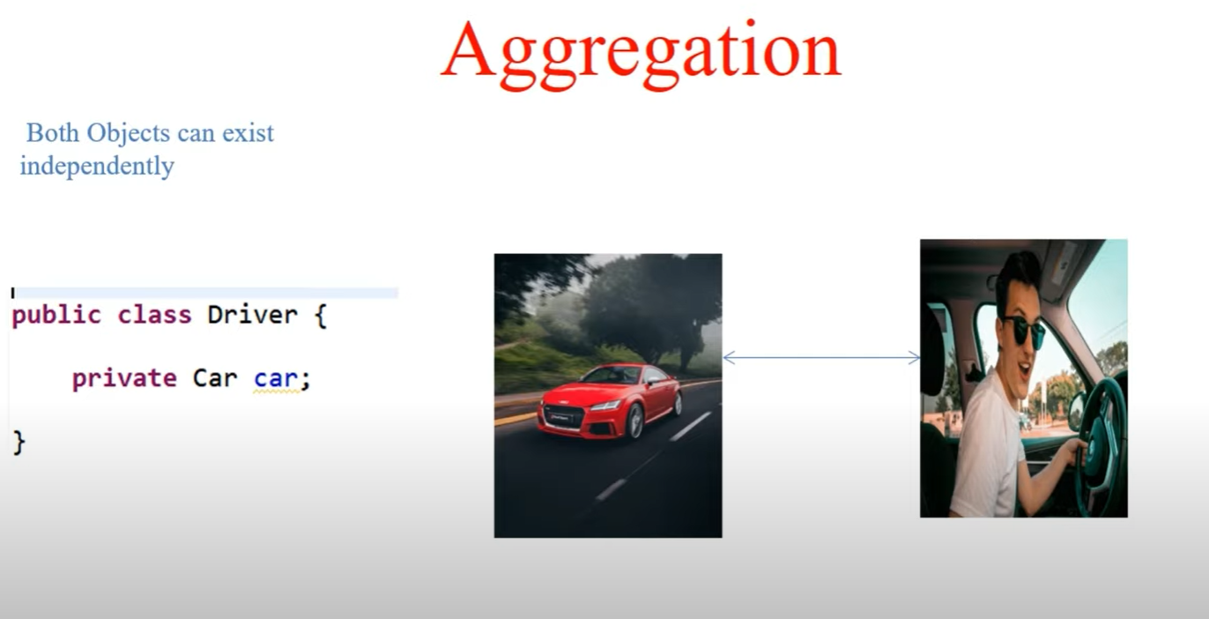

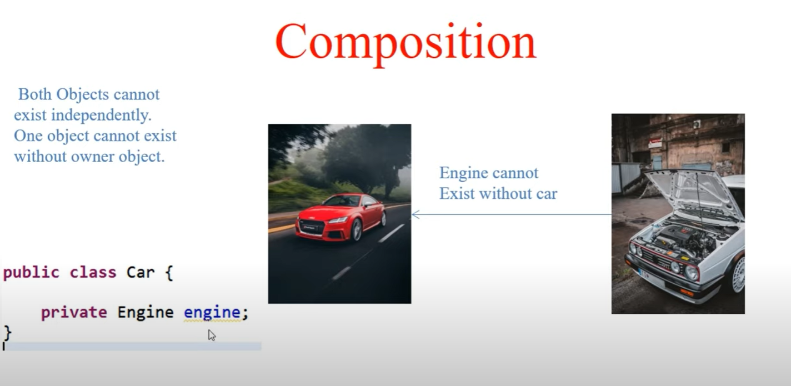

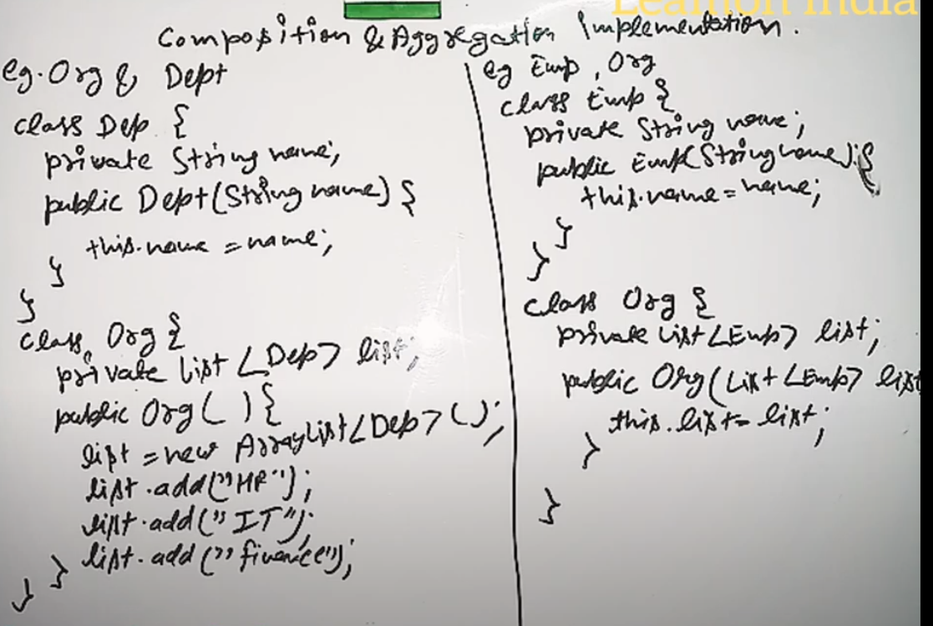

**PHASER VS CYCLIC BARRIER VS COUNTDOWN LATCH**

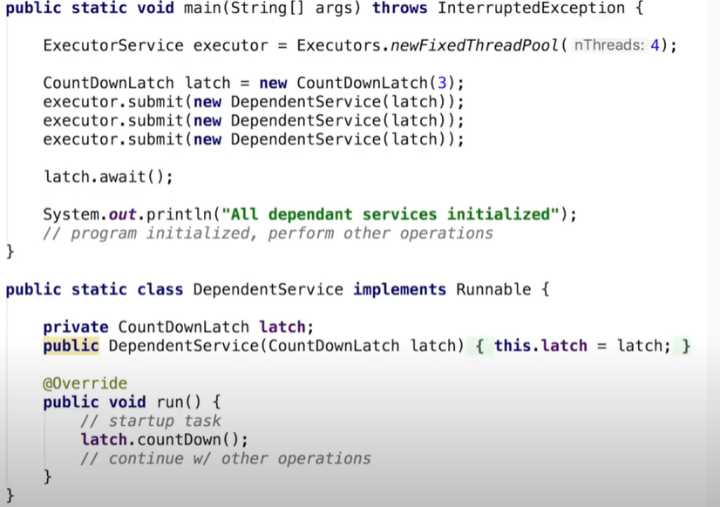

**In count down latch we specific a number and then in the runnable class method we can call the count down method which would decrement the count**

**When the count of the latch reaches 0 then the latch.await() method continues further.**

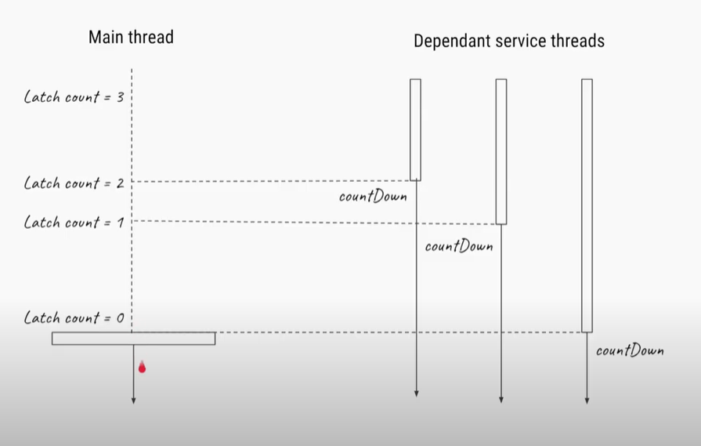

**PHASER AS COUNTDOWN LATCH**

**The behaviour of phaser is same like countdown latch but the only difference is that the method nomenclature is different**

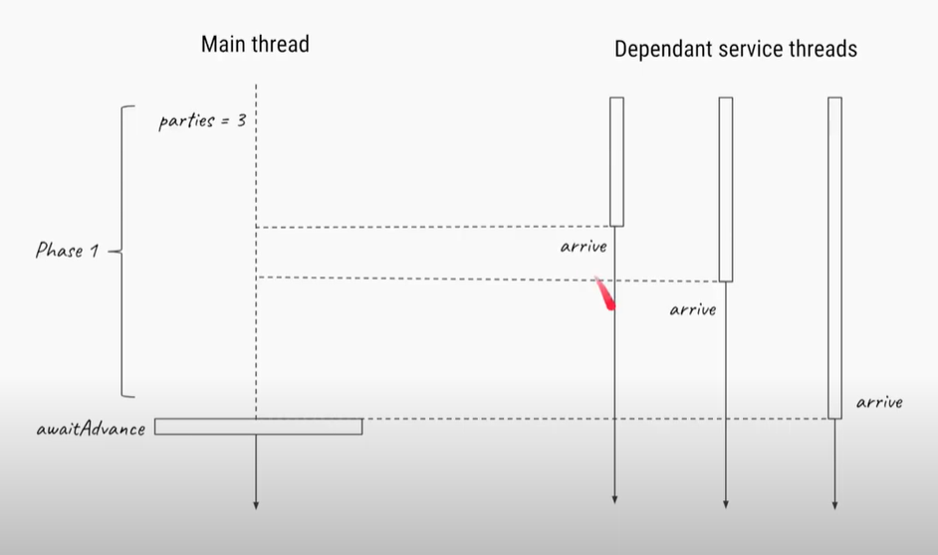

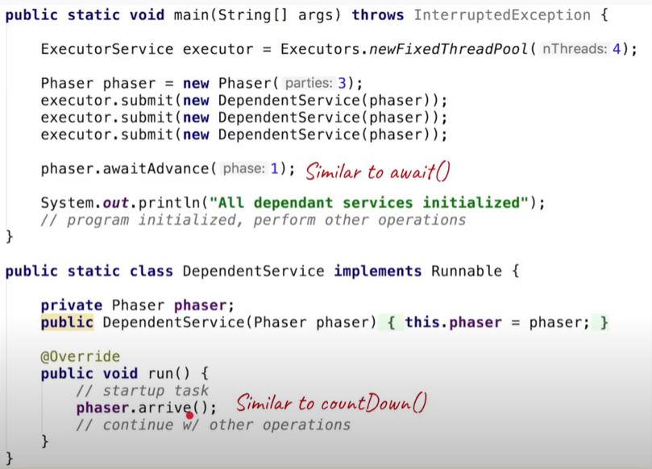

**CYCLIC BARRIER**

**If you want all threads to wait for each other to reach a common point and once all reach that point then continue further, we could use Cyclic barrier**

**Example : Lets say for a race we want all the players to reach a common point (eg starting point) and once all players reach there we could start with the race**

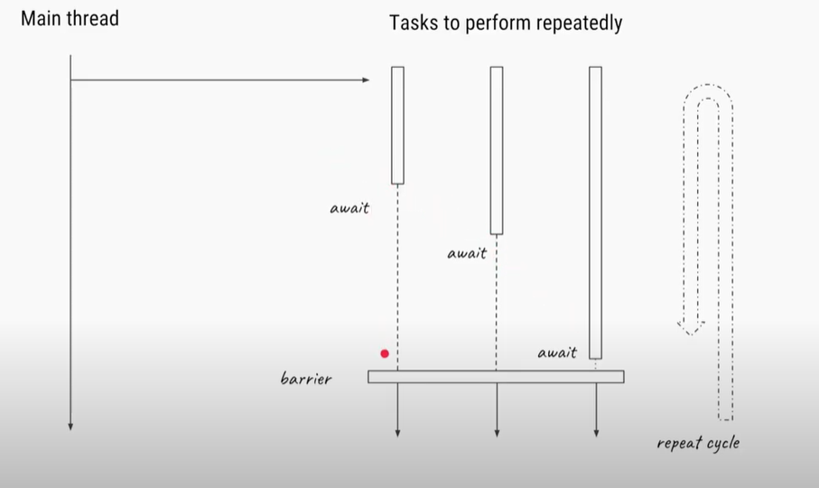

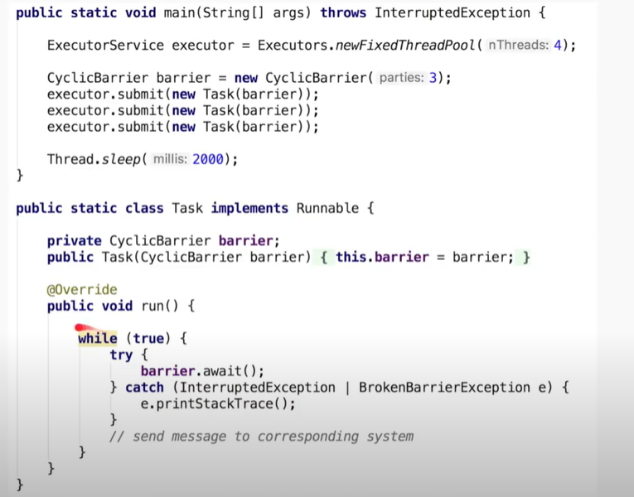

**PHASER AS CYCLIC BARRIER**

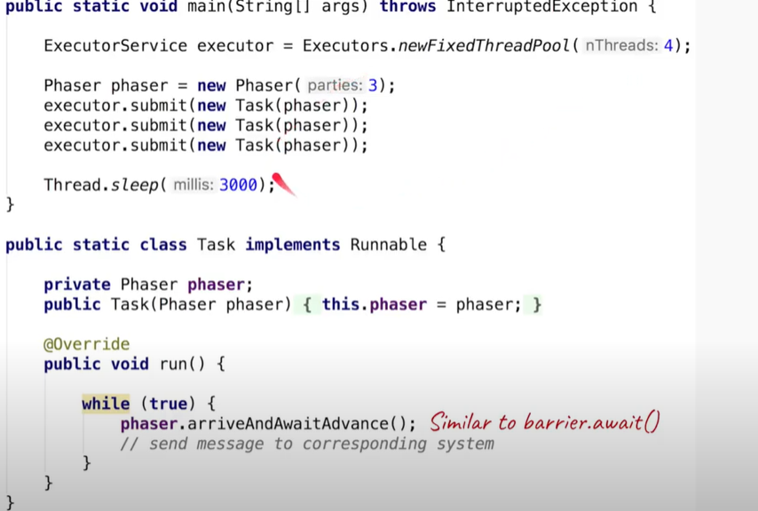

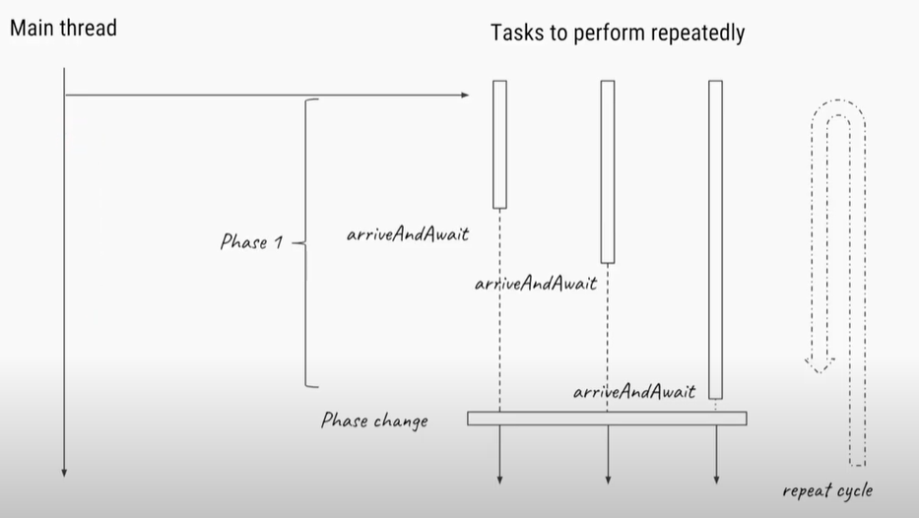

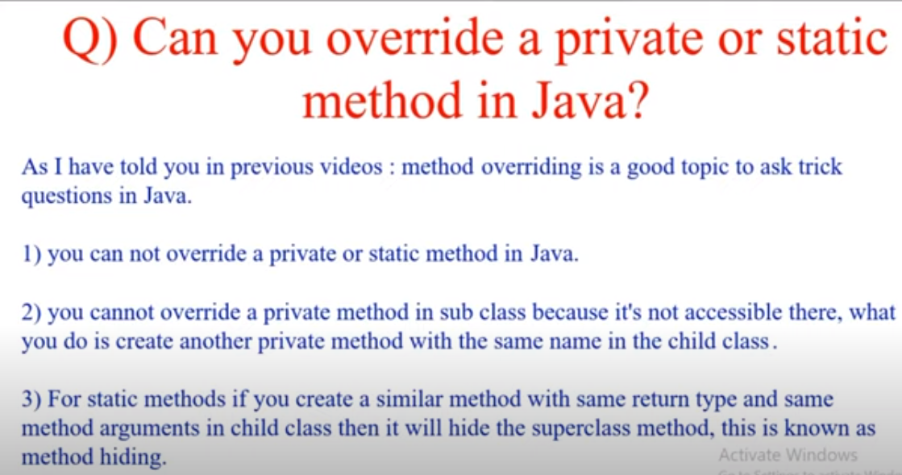

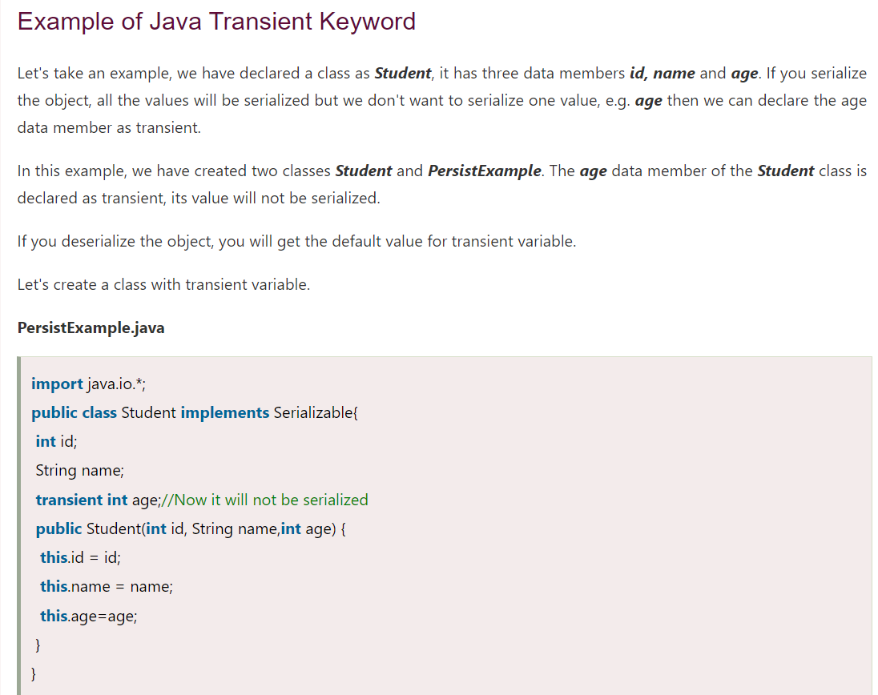

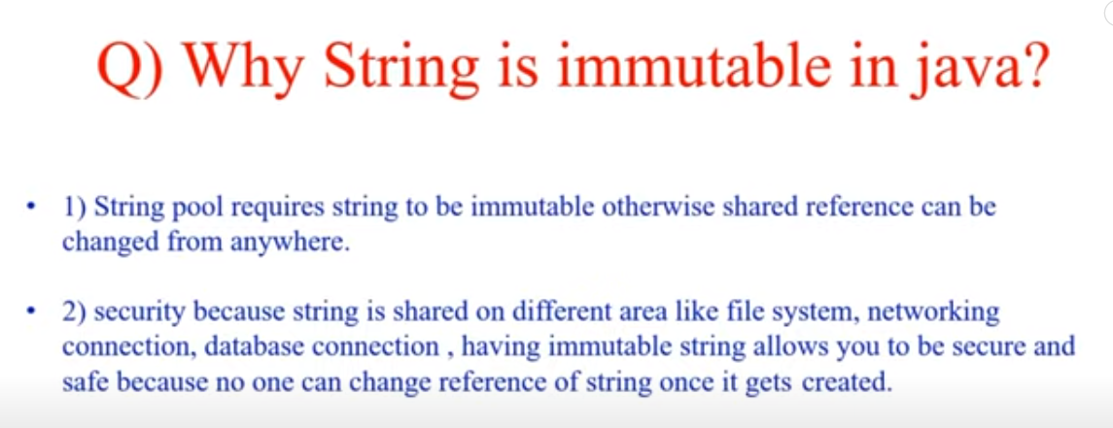

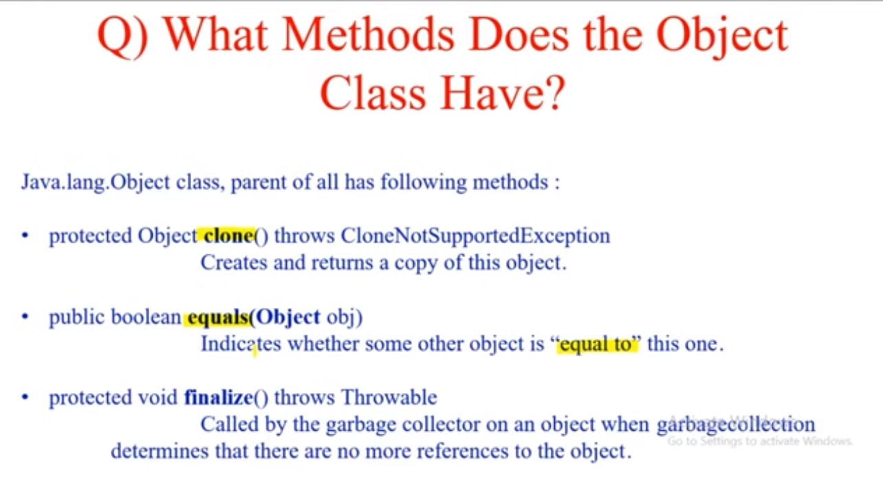

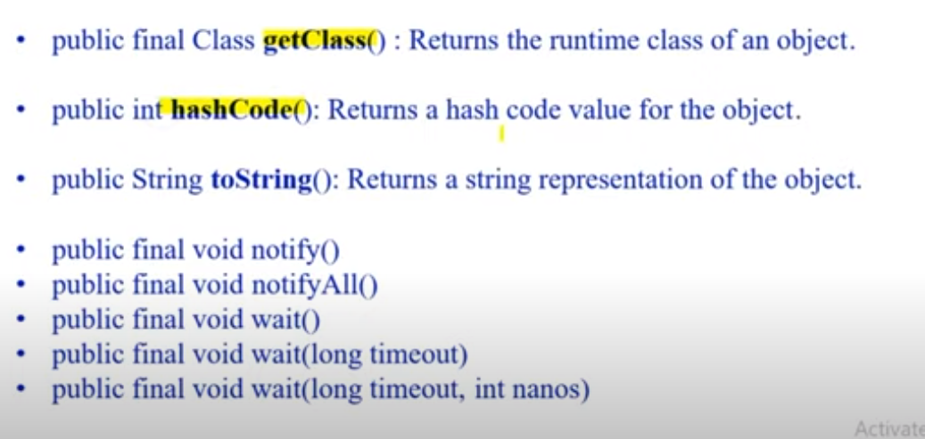

[Default hashCode() implementation for Java Objects](https://stackoverflow.com/questions/49172698/default-hashcode-implementation-for-java-objects)

By default (5), it is using Marsaglia XOR-Shift algorithm, that has nothing to do with memory.

This is not very hard to prove, if you do:

System.out.println(new Object().hashCode());

multiple times, in a new VM all the time - you will get the same value, so Marsaglia XOR-Shift starts with a seed (always the same, unless some other code does not alter it) and works from that.

But even if you switch to some hashCode that is memory based, and Objects potentially move around (Garbage Collector calls), how do you ensure that the same hashCode is taken *after* GC has moved this object? Hint: indentityHashCode and Object headers.

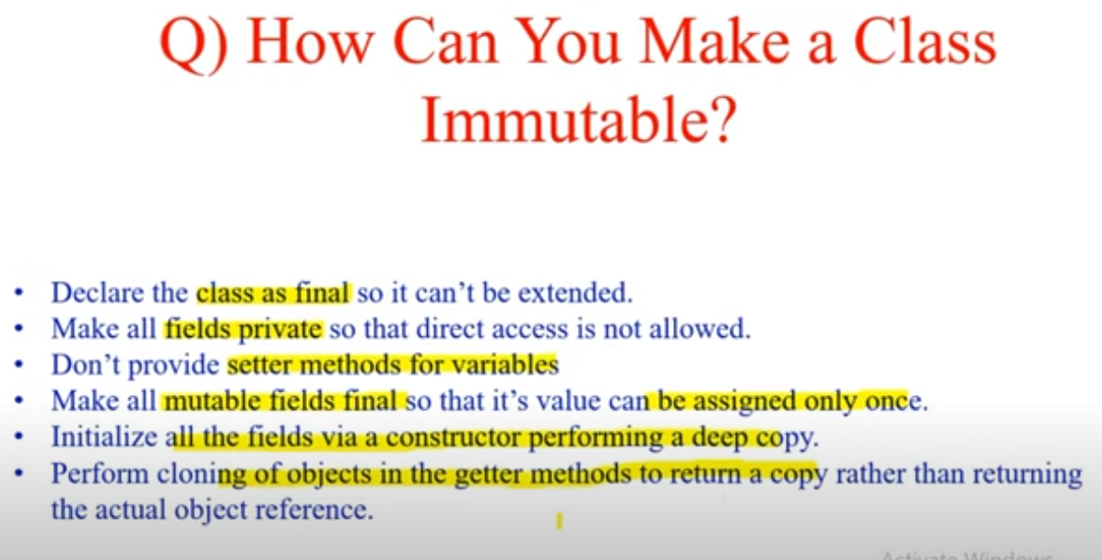

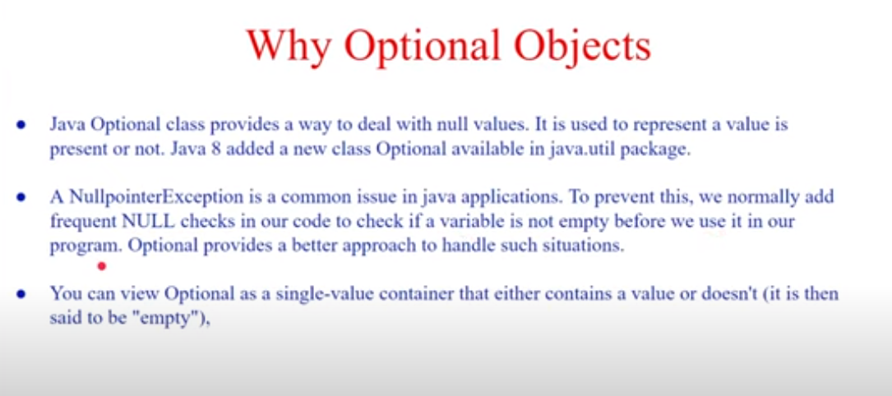

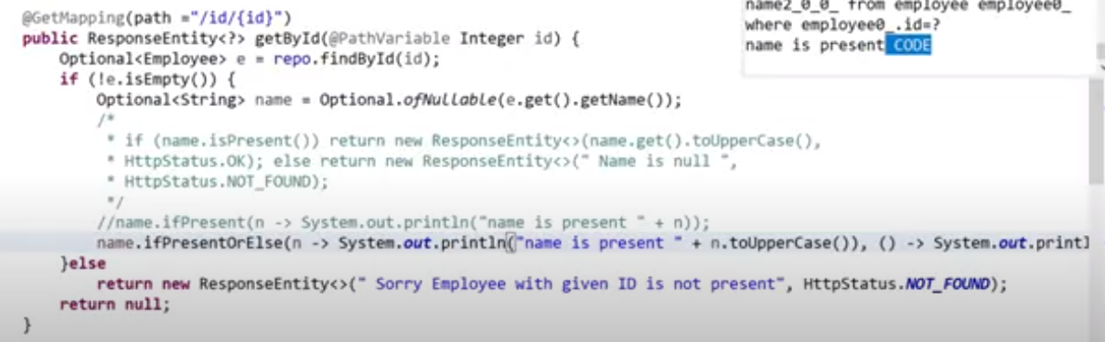

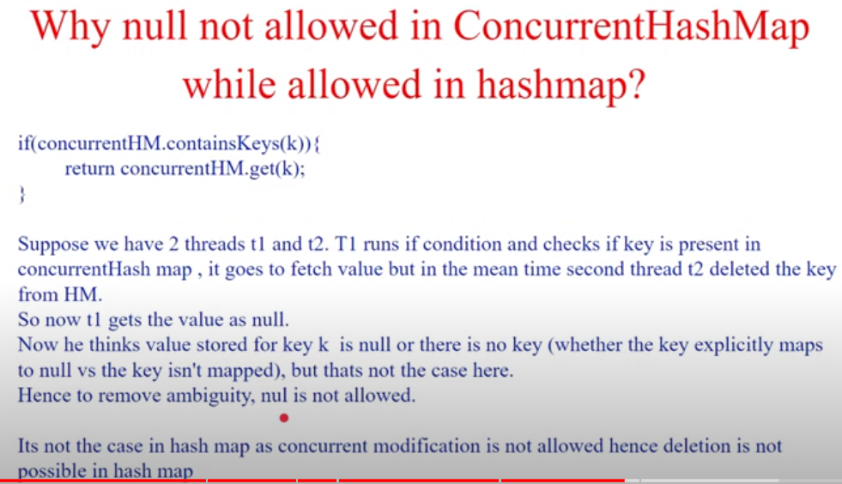

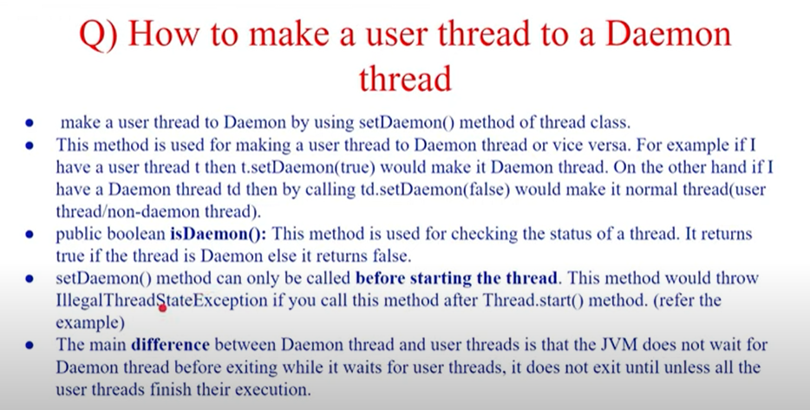

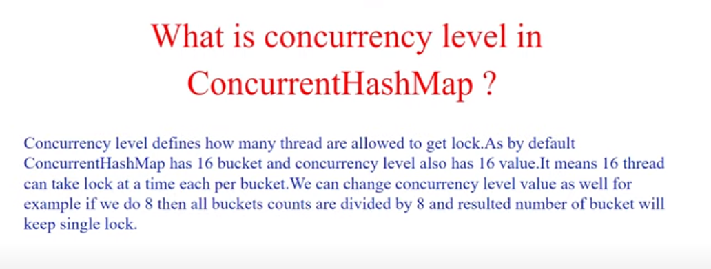

If concurrency level(CL) is 8 and bucket size(BS) is 16 then the segment would be (BS/CL) = 16/8 =2

So 2 buckets together will give one lock to one thread. In below ss 0 and 1 bucket lock is acquired by one thread

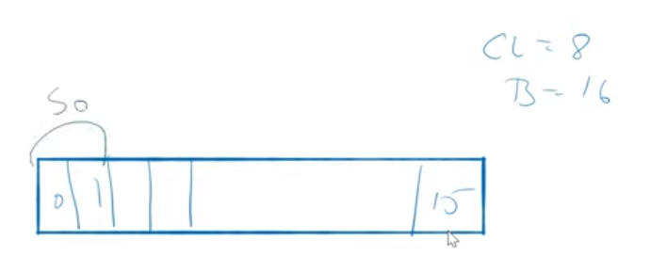

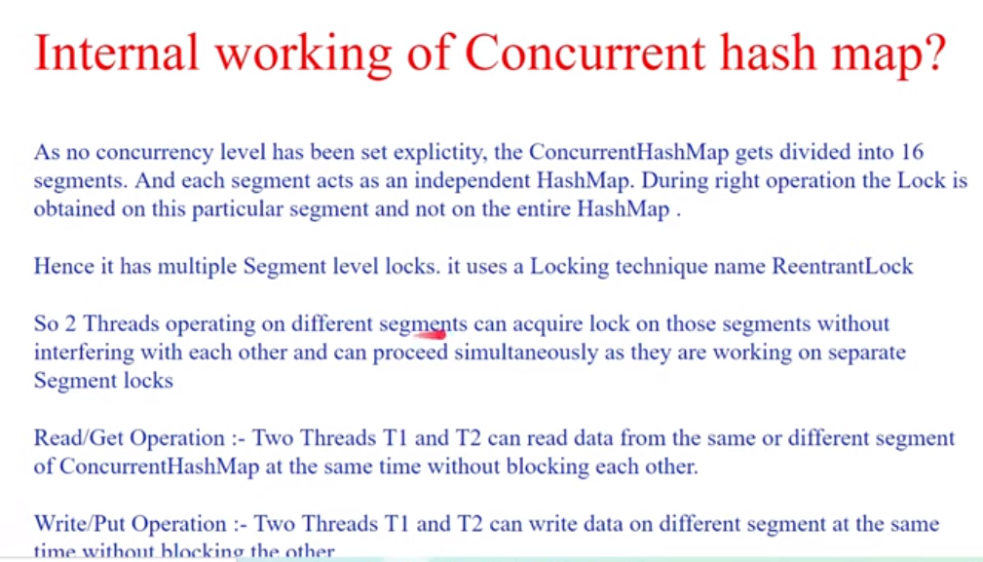

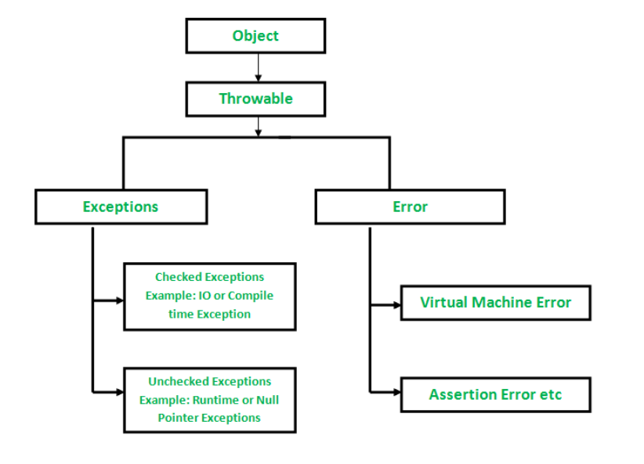

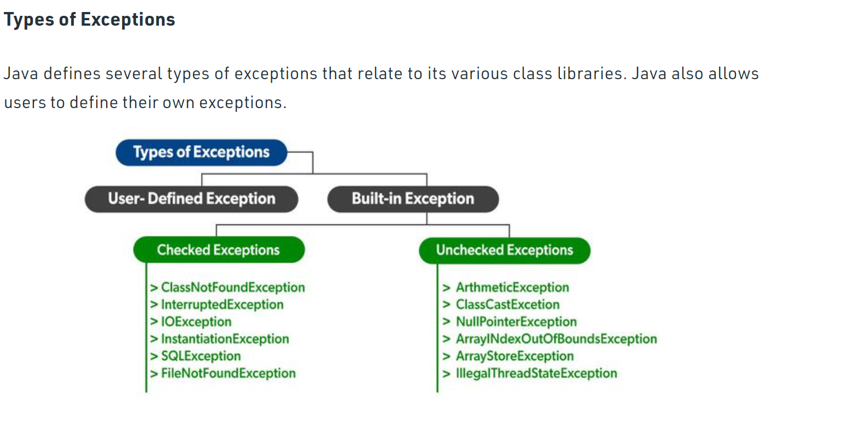

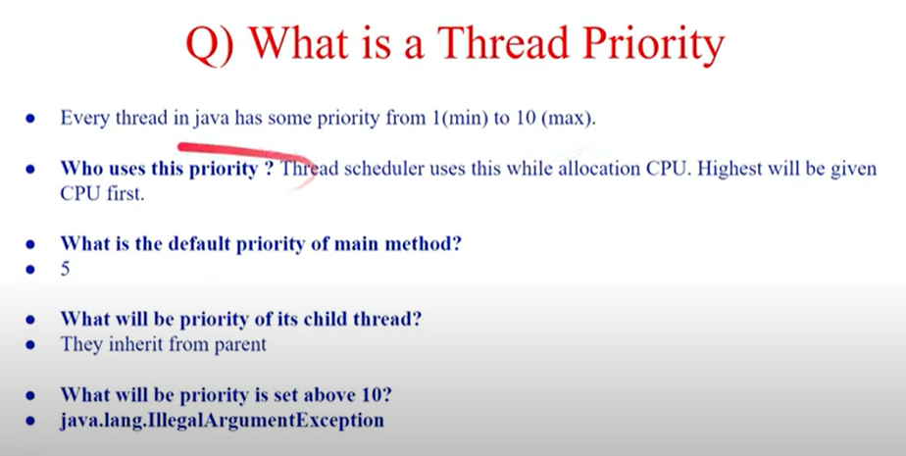

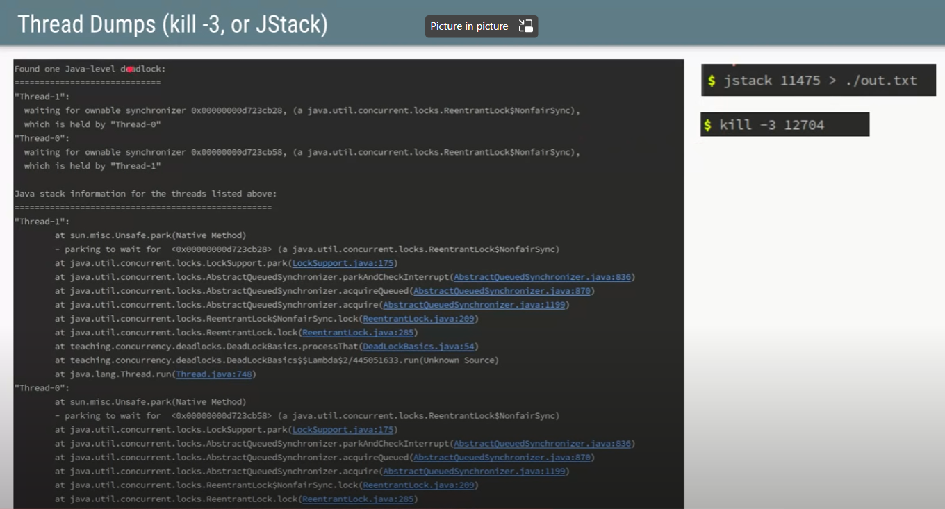

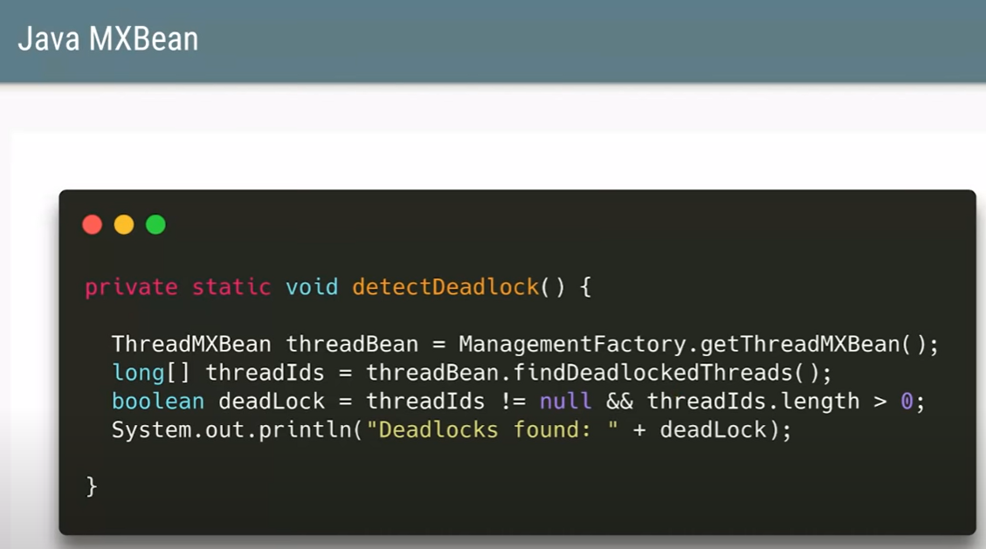

This code will help us understand if any thread are in deadlock

As you can see there is a deadloack scenario here where Thread 0 is waiting on Thread 1 and visa versa

In order to get thread dump we can use any of 2 commands specified in ss

